Q1.
Both the Caesar and Vernam ciphers are symmetric ciphers, whereas a public and private key encryption system is an asymmetric cipher system.
Explain the difference between a symmetric and an asymmetric cipher system
_______________________________________________________________________
_______________________________________________________________________
_______________________________________________________________________
_______________________________________________________________________
_______________________________________________________________________
(Total 1 mark)
Q2.
Many computerised cipher systems use asymmetric encryption methods to resolve the key exchange problem that is associated with symmetric ciphers, such as the Vernam and Caesar ciphers.
Explain what the key exchange problem is, in relation to a symmetric cipher.
_______________________________________________________________________
_______________________________________________________________________
_______________________________________________________________________
_______________________________________________________________________
_______________________________________________________________________
_______________________________________________________________________
_______________________________________________________________________
(Total 2 marks)
Q3.
A message is to be transmitted from computer A to computer B. The message will be encrypted using asymmetric encryption. To enable computer B to authenticate that the message was sent by computer A, a digital signature will also be sent with the message.
Explain how computer B will decrypt the message and verify that it was sent by computer A.
In your response you should refer to the specific keys that will be used in this process.
You do not need to explain how computer A will encrypt the message or create the digital signature.
_______________________________________________________________________
_______________________________________________________________________
_______________________________________________________________________
_______________________________________________________________________
_______________________________________________________________________
_______________________________________________________________________
_______________________________________________________________________
_______________________________________________________________________
_______________________________________________________________________
_______________________________________________________________________
_______________________________________________________________________
_______________________________________________________________________
(Total 4 marks)
Q4.
To access an exam paper on the AQA website a student’s computer might need to make use of a Domain Name System (DNS) query which is transmitted to a DNS server.
(a) What is the purpose of a DNS server?
___________________________________________________________________
___________________________________________________________________
(1)
(b) In some circumstances the student’s computer will not need to contact a remote DNS server to access a resource.
Describe two situations when a DNS query will not be sent to a DNS server.
Situation 1 __________________________________________________________
___________________________________________________________________
___________________________________________________________________
Situation 2 __________________________________________________________
___________________________________________________________________
___________________________________________________________________
(2)
(Total 3 marks)
Q5.
A message is to be transmitted from Computer A to Computer B. For security reasons, the message will be encrypted.
(a) What is encryption?
___________________________________________________________________
___________________________________________________________________
(1)
The message that is being transmitted will be encrypted and decrypted using public and private keys. The figure below shows the encryption and decryption processes. The symbols to in the figure represent the names of keys.
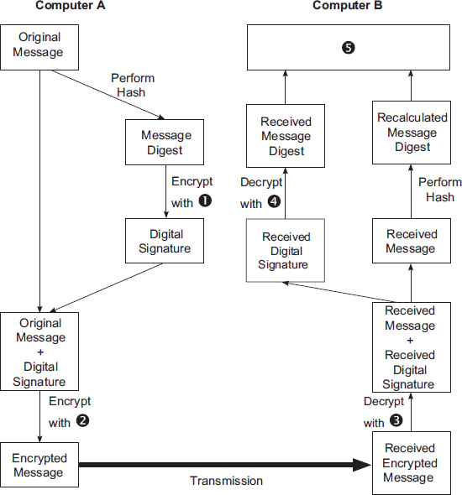
(b) State the names of the keys that are represented by each of the symbols to .

Label | Key Name
(2)
(c) Describe the process that will take place at the position labelled .
___________________________________________________________________
___________________________________________________________________
___________________________________________________________________
(1)
(d) State two purposes of the addition of the digital signature to the message.
Purpose 1: __________________________________________________________
___________________________________________________________________
Purpose 2: __________________________________________________________
___________________________________________________________________
(2)
(Total 6 marks)
Q6.
Between 2008 and 2010, a company that was gathering data for an online mapping system, using cars fitted with cameras and WiFi equipment, collected some information that was being transmitted on personal WiFi networks. The company apologised for doing this and an investigation found that a small number of software developers had been responsible for adding this functionality to the mapping system data collection software.
In the context of this example, discuss:
• how it was possible for this data to be collected.
• what steps the owners of the networks could have taken to prevent the data from being collected.
• what legal and ethical issues might have arisen as a result of collecting this data.
• what lessons the company might have learnt from the incident and how their practices might have changed as a result of it.
In your answer you will be assessed on your ability to follow a line of reasoning to produce a coherent, relevant and structured response.
(Total 12 marks)

